Assessment Front Sheet and Student Declaration

Course | NC Computing
Lecturer’s Name | Karen Mackay/Martin Little/Suzanne Irvine/Steven O’Connor
Student’s Name / ID | Paige Matthews 18020860
Unit / Module Title | NPA Software Development
Unit / Module Ref No | GL4W 46
Learning Outcome(s) | Part 1
Date Due | 15th Nov 2020 | Date Submitted | 22th Nov  2020
No. of Attempt | 1 / 2 | Word Count (if applicable)

Plagiarism occurs when a writer deliberately uses someone else’s language, ideas or other original (not common-knowledge) material without acknowledging its source.

This definition applies to texts published in print or on-line, to manuscripts, and to the work of other students.

You must be clear that you understand this declaration before you sign it – ask your lecturer or Personal Academic Tutor for help explaining it if necessary.

Student Declaration
I confirm that the materials submitted within are my own work. Where I have used ideas/words that are not my own, these are clearly referenced.

I understand the consequences of submitting work which is plagiarised range from possibly failing this assessment, up to and including student disciplinary procedures being applied.
Student Signature | Paige Matthews
Date | 27th November 2020

Contents

Pontoon

Brief
Application name is Pontoon. This is a website made to allow a verity of users to play pontoon. This game is a one player game where the player is playing against the computer or the house. In the game the “pack” of cards is 2 through 10, there are no Aces, Jacks, Queens or Kings. The house or computer always has 18. The player draws two cards at random by clicking buttons, they are added together and the player can draw another random card. The goal of the game is for the player to get their total number to 21, if they go over 21, then they lose and house wins, if they go over 18 and under 21 then they win and the house loses. The maximum number of cards the player can draw is 5 and they can stop at any amount of cards under 5. This application is aimed at anyone over the age of 12, given the fact they can use an internet browser.

Requirements Specification
Functional Requirements
Non-functional Requirements
User Interface Requirements
Hardware needed – one of the below that can access an internet browser | Software used | Media required
PC | Visual Studio Code | Web browser
Smartphone | HTML | Internet
Tablet | CSS | Chrome
Mouse/ touchscreen | JavaScript | Microsoft Edge

Environment
Tools used and why:
Sounds:
Copyright free etc

Media Asset | Source | Description
 | Youtube | Background music
 | Youtube | Clapping sound
 | https://www.pexels.com | Picture of card dealer
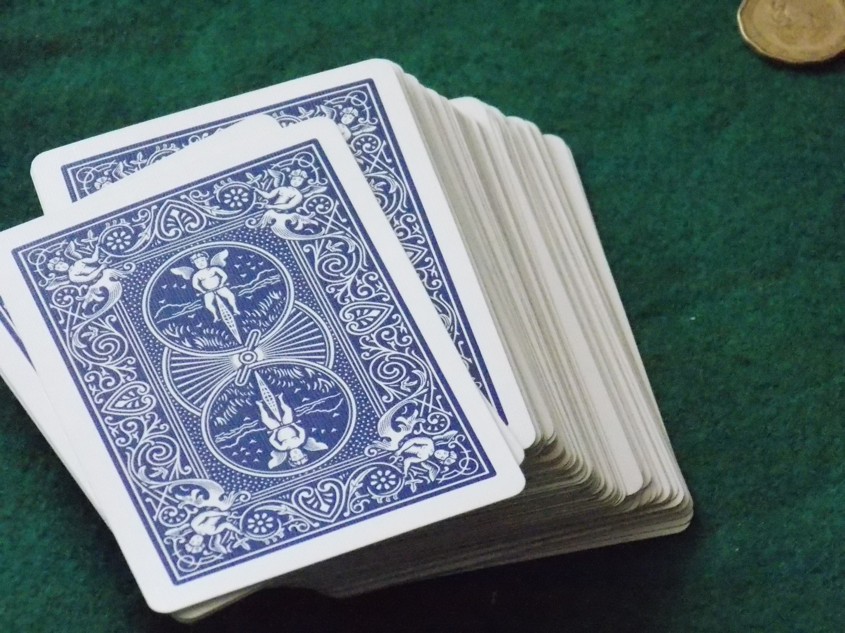 | https://www.pexels.com | Picture of a deck of cards
 | https://www.pexels.com | Picture of cards on a table
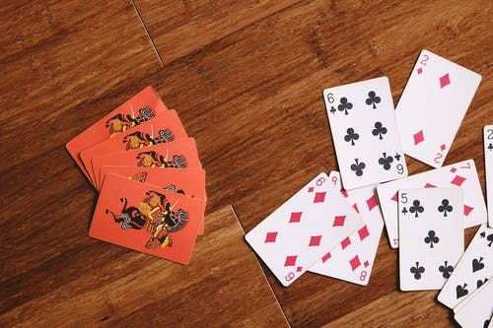 | https://www.pexels.com | Picture of a spread of cards on a table

Flowchart
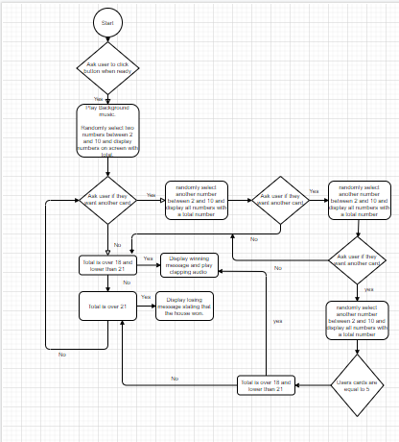

Site Map
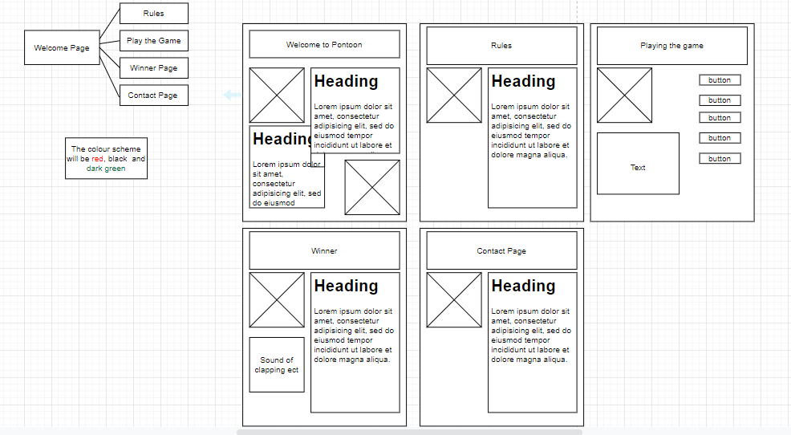

Wireframes/Storyboard

Gantt chart
